85 Render - Freestyle
Freestyle 2
What is FreeStyle? 2
The Big Picture 5
Known Limitations 5
Core Options 6
Viewmaps 6
Advanced Options 7
Parameter Editor 7
Line Set 8
Selection by Visibility 9
Selection by Edge Types 10
Edge Marks 12
Selection by Face Marks 14
Selection by Group 16
Selection by Image Border 16
Line Style & Modifiers 16
Stroke 17
Chaining 18
Splitting 18
Sorting 19
Selection 19
Caps 19
Dashed Line 20
Color 20
Modifiers 20
Along Stroke 21
Distance from Camera 21
Distance from Object 21
Material 22
Noise 22
Tangent 23
3D Curvature 23
Crease Angle 24
Alpha 25
Modifiers 26
Along Stroke 26
Distance from Camera 27
Distance from Object 27
Material 28
Noise 28
Tangent 29
3D Curvature 29
Crease Angle 30
Thickness 31
Modifiers 32
Along Stroke 32
Calligraphy 32
Distance from Camera 33
Distance from Object 34
Material 34
Noise 35
Tangent 35
3D Curvature 36
Crease Angle 37
Geometry 37
Modifiers 38
2D Offset 38
2D Transform 39
Backbone Stretcher 40
Bezier Curve 40
Blueprint 40
Guiding Lines 41
Perlin Noise 1D 41
Perlin Noise 2D 42
Polygonization 42
Sampling 42
Sinus Displacement 43
Spatial Noise 43
Tip Remover 44
Simplification 44
Python Scripting Mode 44
Writing Style Modules 46
Selection 46
Chaining 47
Splitting 48
Sorting 48
Stroke creation 48
User control on the pipeline definition 49
Freestyle SVG Exporter 49
Options 50
Exportable Properties 50
Animations 51
Exporting Fills 52
Link 52
Video 52
Video Tutorial 52
Tutorial 53

Freestyle

What is FreeStyle?
Freestyle is an edge- and line-based non-photorealistic (NPR) rendering engine. It relies on mesh data and z-depth information to draw lines on selected edge types. Various line styles can be added to produce artistic (“hand drawn”, “painted”, etc.) or technical (hard line) looks.
The two operating modes - Python Scripting and Parameter Editor - allow a powerful diversity of line styles and results. Line styles such as Japanese big brush, cartoon, blueprint, thickness-with-depth are already pre-scripted in Python. The Parameter Editor mode allows intuitive editing of features such as dotted lines and easy setup of multiple line types and edge definitions. On top of all of that, with the introduction of line style modifiers, the sky is the limit!
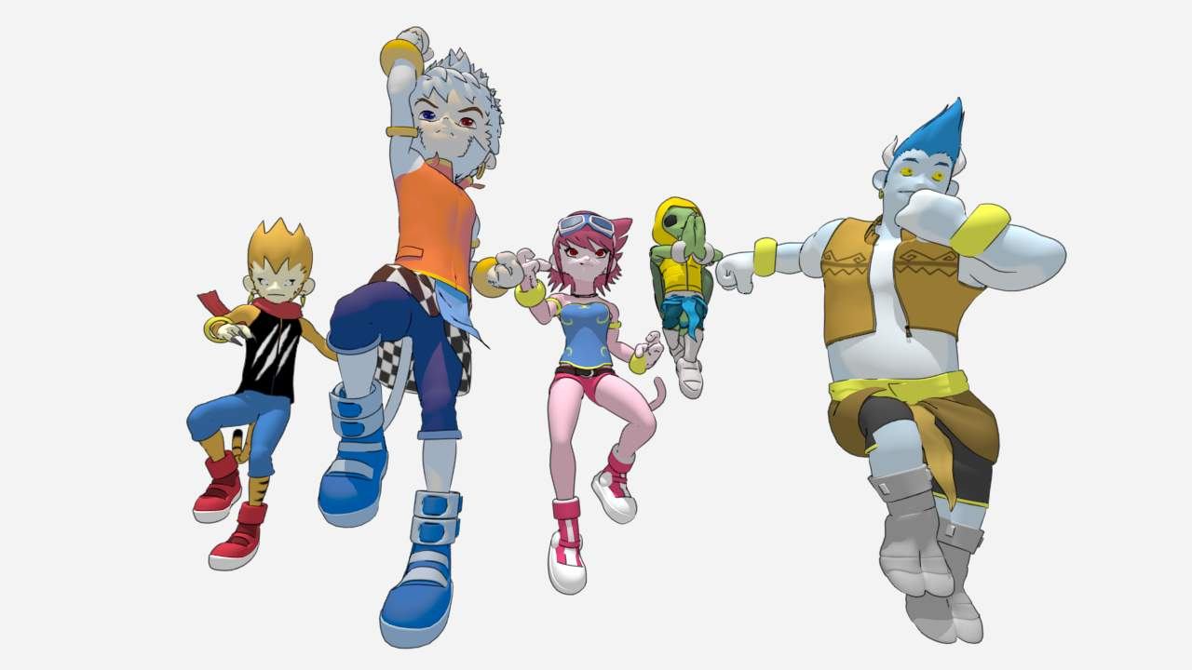
A cartoon scene from OHA Studio (the .blend file). © Mechanimotion Entertainment.
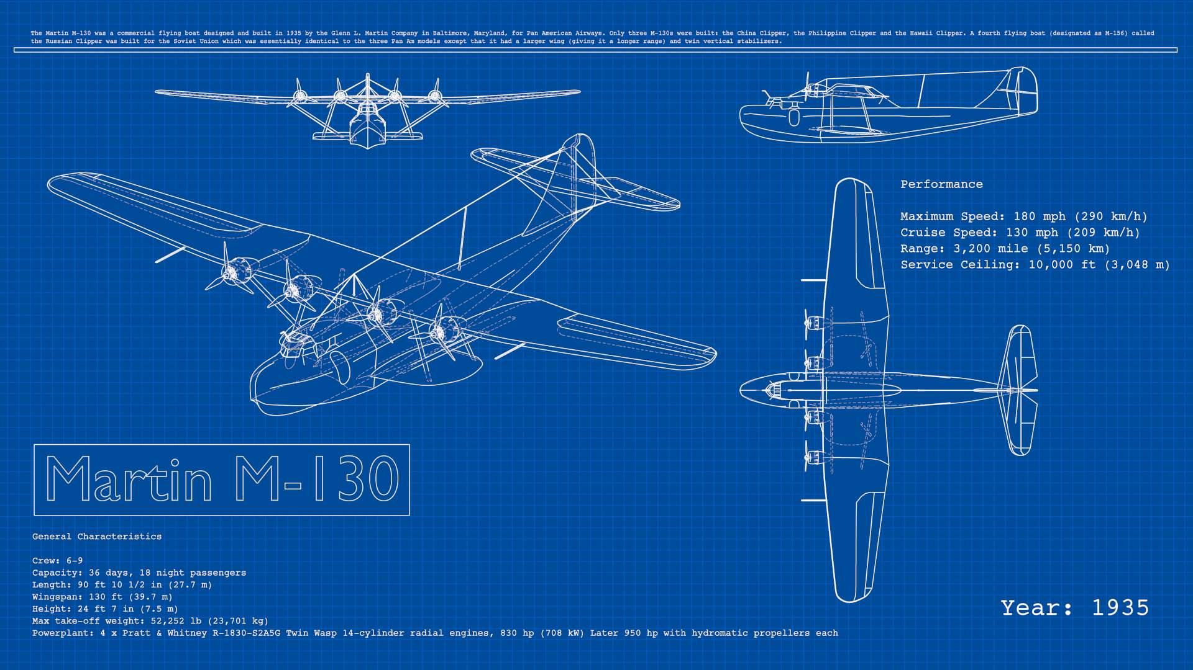
Blueprint render of Martin M-130 from 1935 by LightBWK. CC0. WARNING: HEAVY FILE! DESIGNED FOR STRESS TEST Bforartists TO THE LIMITS & MAY CRASH Bforartists. (File:M-130Blueprint.zip)
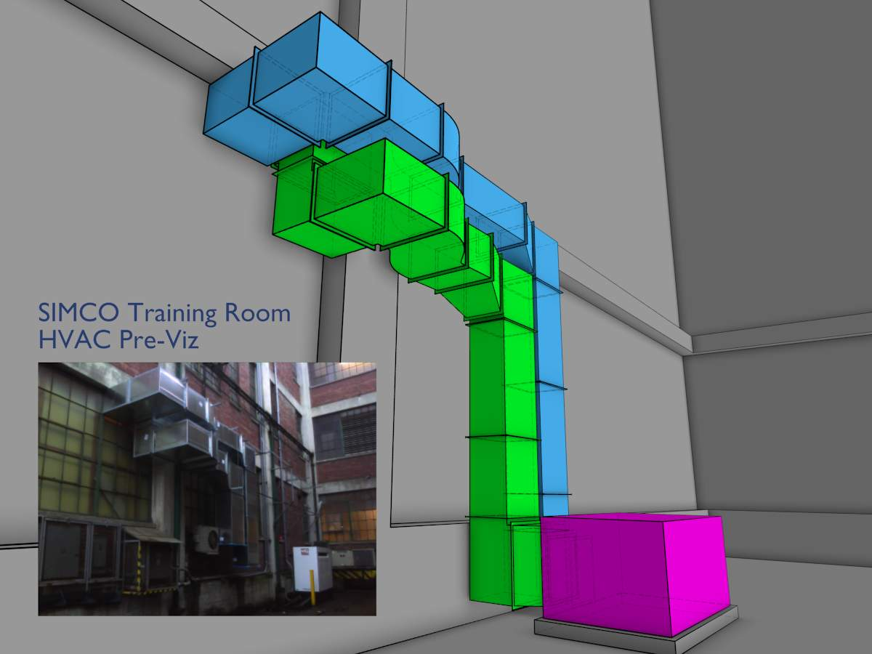
HVAC Pre-Viz by Lee Posey. CC0 (File:HVACPreViz.zip)
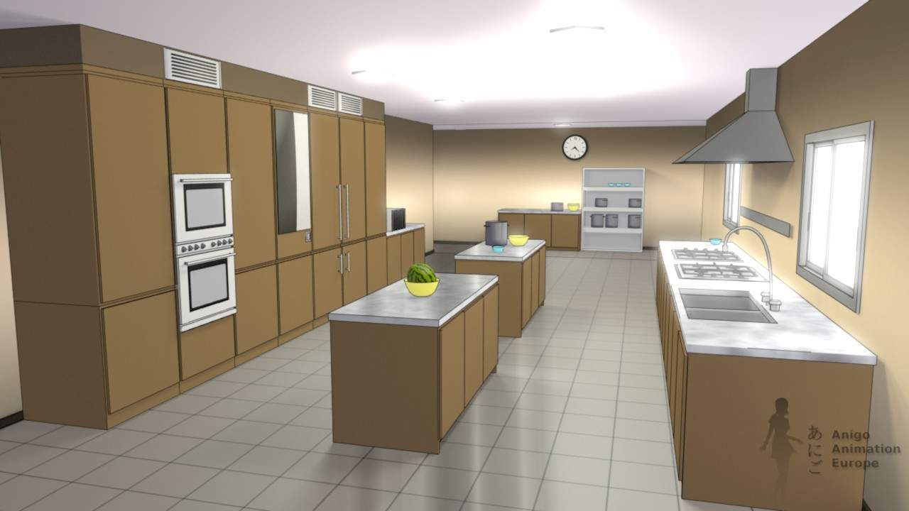
Kitchen by Vicente Carro. © AnigoAnimation
More artwork can be found at http://wiki.Bforartists.org/index.php/Dev:Ref/Release_Notes/2.67/FreeStyle#Freestyle_Artwork_Showcase

The Big Picture
- Activate FreeStyle by Properties window –> Render tab –> FreeStyle panel, tick check box. Please note that FreeStyle is only available for the Bforartists Internal renderer.
- Freestyle settings are located in the new Render Layers context.
- One render layer can only have one viewmap. A viewmap holds the edge detection settings (Crease Angle, Culling toggle, Face Smoothness toggle, Material Boundaries toggle, Sphere Radius and Kr Derivative Epsilon advanced options).
- A viewmap can have multiple line sets.
- A line set controls which line types and selections will be rendered, from lines based on your scene.
- Each line set uses one line style (which can be shared between multiple line sets).
- A line style tells Freestyle how to render the linked line sets in terms of color, alpha, thickness and other aspects.
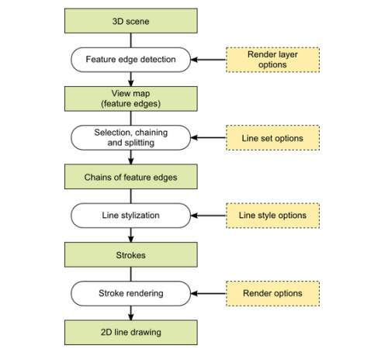
block diagram of Freestyle view map and processes

Known Limitations
- Highly memory demanding: All mesh objects in a render layer are loaded at once.
- Only faced mesh objects are supported. The following kinds of meshes are ignored:
  - Mesh faces with wire materials.
  - Mesh faces with completely transparent materials.
  - Mesh faces with the Cast Only material option enabled.
- Transparent faces are treated as opaque faces.
- No edges at face intersections are detected yet.
- Layer masks do not work with Freestyle.
- Freestyle rendering results do not have any Z depth information.
- Panoramic cameras are not supported.

Core Options

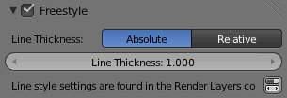
Freestyle core options.
Activating Freestyle in the Render context of the Buttons window will give you the following options:
Line Thickness
There are two different modes for defining the base line thickness:
Absolute
The line thickness is given by a user-specified number of pixels. The default value is 1.0.
Relative
The unit line thickness is scaled by the proportion of the present vertical image resolution to 480 pixels. For instance, the unit line thickness is 1.0 with the image height set to 480, 1.5 with 720, and 2.0 with 960.
Line Thickness
Only for Absolute line thickness: base line thickness in pixels, 1.0 by default.

Viewmaps

There is only one viewmap per render layer. It controls the edge detection parameters. Which detected edges are actually rendered, and how, can be controlled either through the user-friendly parameter editor, or powerful but complex Python scripting.
Face Smoothness
When enabled, Face Smoothness will be taken into account for edges calculation.
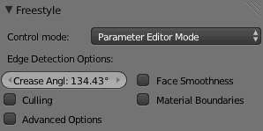
Parameter Editor Mode UI
Crease Angle
If two adjacent faces form an angle less than the defined Crease Angle, the edge between them will be rendered when using Crease edge type selection in a line set. The value also affects Silhouette edge type selection.
Culling
Ignore the edges that are out of view (saves some processing time and memory, but may reduce the quality of the result in some cases).

Advanced Options
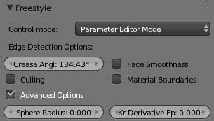
Advanced Options
Sphere Radius It affects the calculation of curvatures for Ridge, Valley and Suggestive Contour edge type selection in a line set.
Kr Derivative Epsilon
It provides you with control over the output of Suggestive Contour and Silhouette edge type selection (further information in this pdf).

Parameter Editor

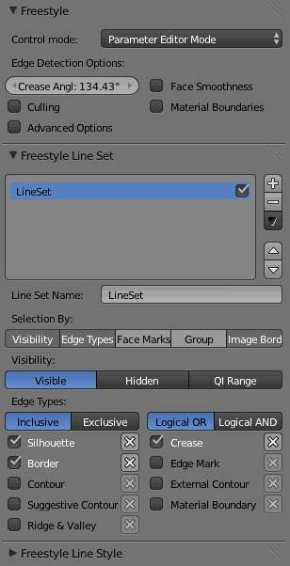
Parameter Editor
The Freestyle Parameter Editor is a user-friendly interface to define and control line sets and line styles.
Line Sets
control which of the edges detected by Freestyle will actually be used (rendered).
Line Styles
control how the selected edges are rendered.
A view map (hence a render layer) can have multiple line sets, and each line set is linked to one line style.

Line Set

A line set selects, among the lines (edges) detected by Freestyle, which ones will be rendered using its attached line style, through various methods.
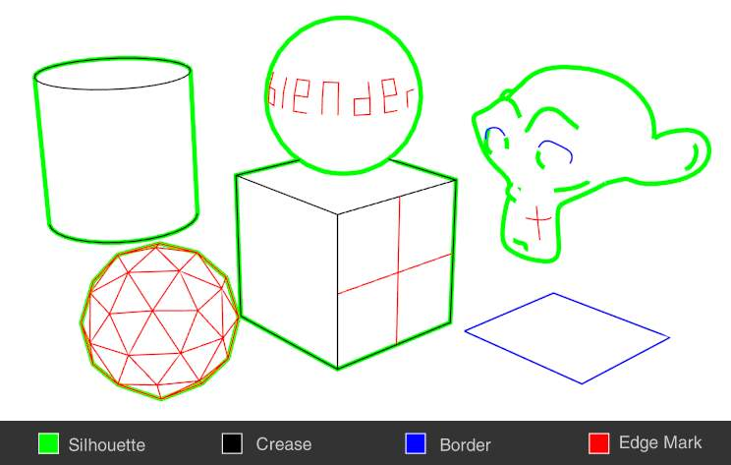
Examples of some basic edge types by LightBWK (File:EdgeType.zip)

Selection by Visibility
There are three choices for selecting edges by visibility.
Visible
Only lines occluded by no surfaces are rendered.
Hidden
Lines occluded by at least one surface are rendered.
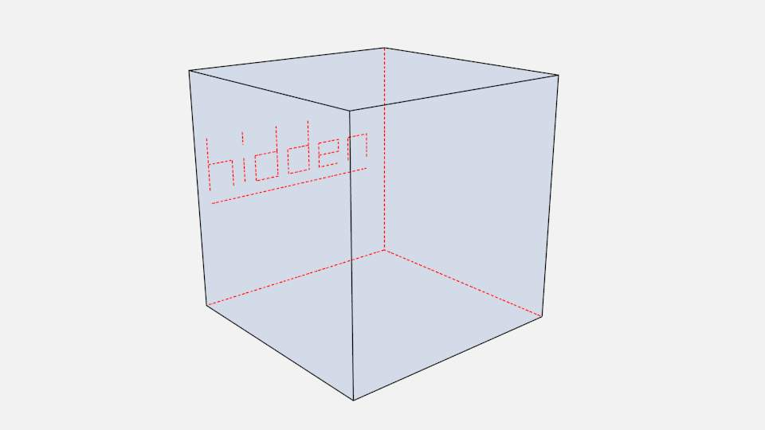
Proof of concept of visible and hidden edges by LightBWK (Sample .blend)
QI Range
QI stands for Quantitative Invisibility. Lines occluded by a number of surfaces in the given range are rendered.
Start and End
Only with QI Range, min/max number of occluding surfaces for a line to be rendered.
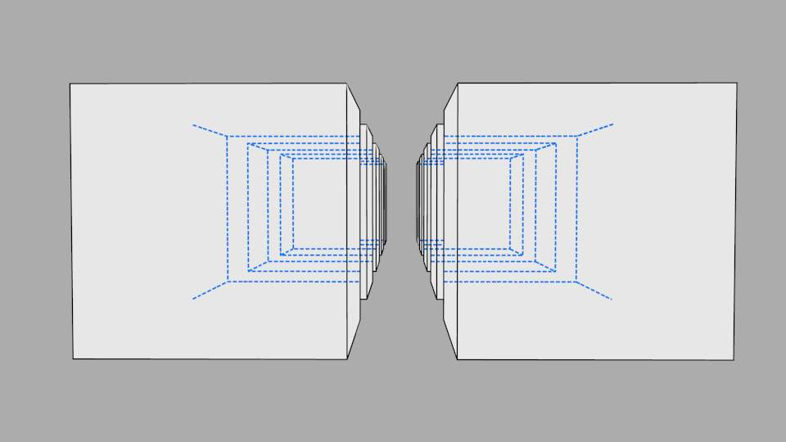
QI Range proof of concept demo, Start: 3, End: 7, by LightBWK (Sample .blend)

Selection by Edge Types
Edge types are basic algorithms for the selection of lines from geometry. When using the parameter editor you have to choose at least one edge type in order to get a render output, but several edge types can be combined in one line set. Edge types can also be excluded from calculation by pressing the X next to them.
Silhouette
Draws silhouettes around your closed objects; it is often good for organic objects (like Suzanne & Sphere), and bad for sharp edges, like a box. It can’t render open mesh objects like open cylinders and flat planes. The output is affected by the Kr Derivative Epsilon viewmap setting.
Crease
Shows only edges whose adjacent faces form an angle greater than the defined viewmap’s Crease Angle.
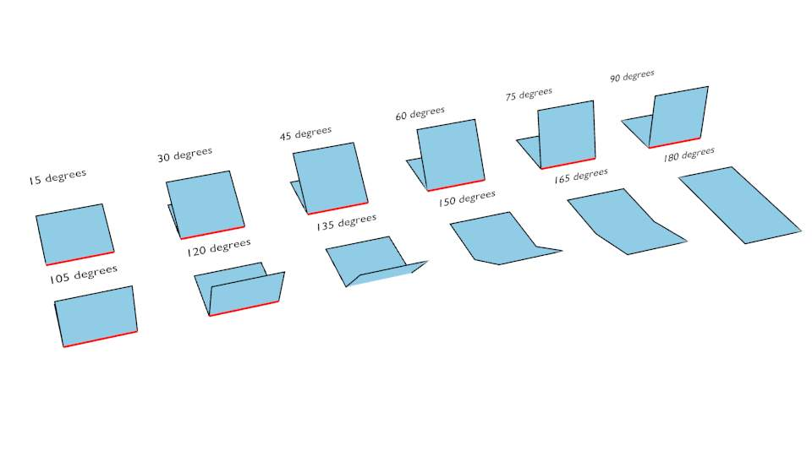
Crease Angle proof of concept for 121º by LightBWK ( the .blend file)
Border
Border is for open/unclosed edge meshes; an open cylinder has an open edge at the top and bottom, and a plane is open all around. Suzanne’s eye socket is an open edge. All open edges will have lines rendered. This depends on the mesh structure.
Edge Marks
Renders marked edges. See Edge Marks for details.
Contour
Draws the outer edges and inner open border.
External Contour
Draws the contour lines, but only on the outer edges.
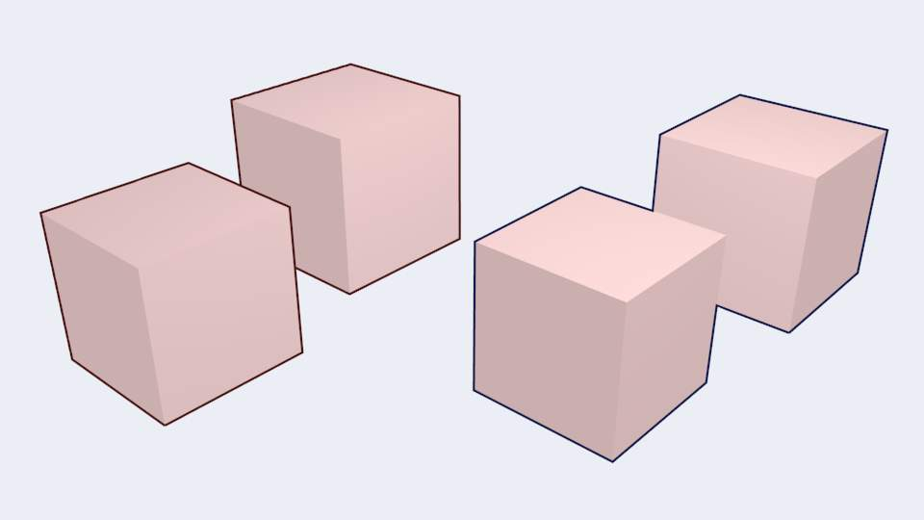
Left pair: Contour; Right pair: External Contour
Suggestive Contour
Draws some lines which would form the contour of the mesh if the viewport was shifted. Depends on your viewmap settings for Kr Derivative Epsilon and Sphere Radius (further information: File:Manual-2.6-Render-Freestyle-PrincetownLinestyle.pdf).
Material Boundary
Draws lines where two materials meet on the same object. Must be activated in the viewmap settings.
Ridge & Valley
Draws ridges and valleys. Depends on your Sphere Radius viewmap settings.

Edge Marks
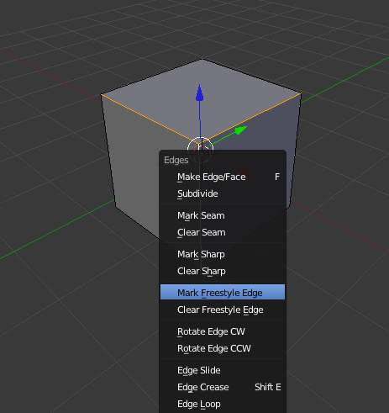
Select and mark Freestyle edges.
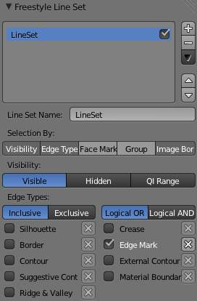
Edge Mark setting in the Line Sets tab.
In edit mode you can mark “Freestyle Edges” in the same manner you can mark “Seams” for UV unwrapping or “Sharp” for edge split. These marked edges are available to render when you select Edge Mark.
This is done as follows:
- Select your mesh and tab into Edit mode.
- Select the edges you want to be marked.
- Press Ctrl-E and select Mark Freestyle Edge.
Edge marks are useful when you want to draw lines along particular mesh edges. The examples below explain the use of edge marks.
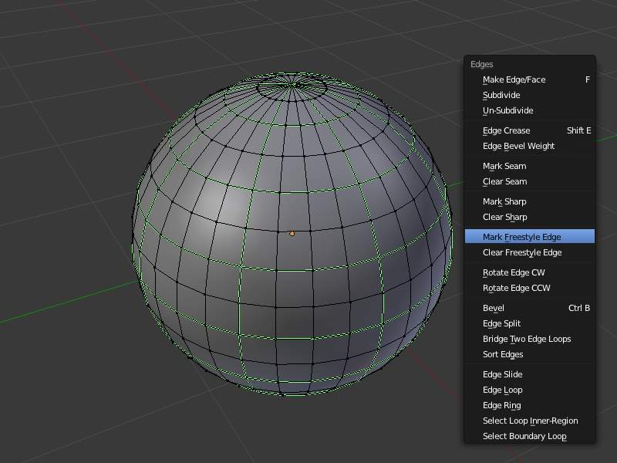  Marking Freestyle Edges in edit mode. | 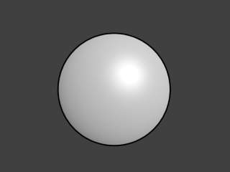  Render without Edge Marks. | 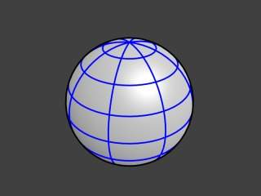  Render with Edge Marks enabled.
The image on the left shows a sphere in Edit mode. The green lines are the edge marks. On the right you see a render without edge marks enabled.
With edge marks enabled, the previously-marked lines are always rendered. You can see the black contour lines and the blue lines that are made with edge marks.
What are edge marks good for?
- When you need to render marks on an almost-flat plane, when other edge types can’t detect any line.
- When you want full control of edge rendering. Often used for edges of squarish shapes.
- Mark the whole base mesh to be rendered for base mesh preview.
What are edge marks not good for?
- Round outer edges (use instead Contour / External Contour / Silhouette).

Selection by Face Marks
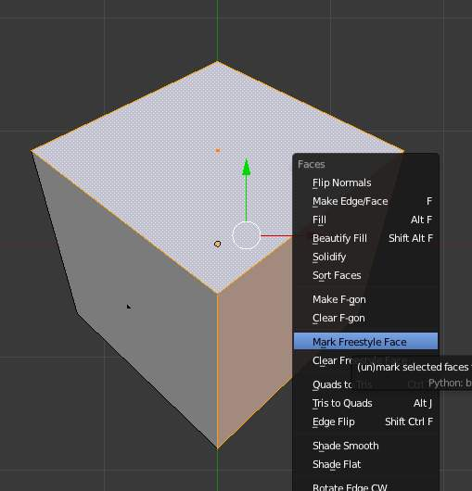
Mark Freestyle Faces.
To set a face mark:
- Select a mesh and tab into Edit mode.
- Select the faces you want to be marked.
- Press Ctrl-F and select Mark Freestyle Face.
Face marks are useful for removing lines from certain areas of a mesh.
In this example, two faces of the default cube are marked like the image on the left. On the right is a render without face marks activated.
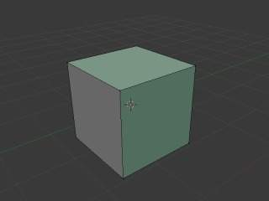  Marked Faces. | 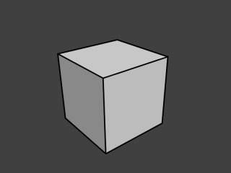  Render Output.
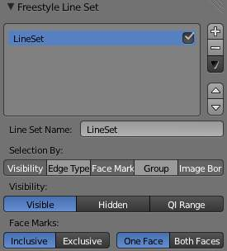
Face mark options.
The line selection can be controlled via inclusion and faces options:
Inclusive / Exclusive
Whether to include or exclude edges matching defined face mark conditions from the line set.
One Face
(De)select all edges which have one or both neighbor faces marked.
Both Faces
(De)select all edges which have both of their neighbor faces marked.
The image below shows the resulting combinations.
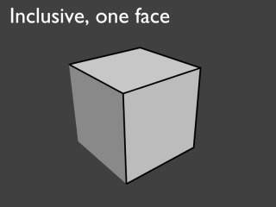  Inclusive, One Face. | 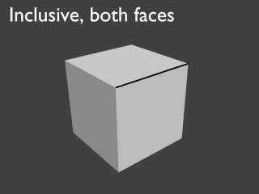  Inclusive, Both Faces.
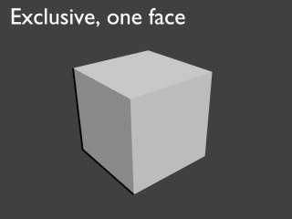  Exclusive, One Face. | 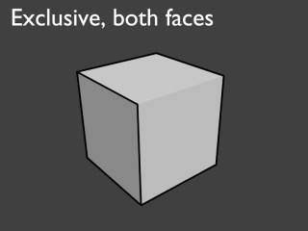  Exclusive, Both Faces.

Selection by Group
You can include or exclude objects for line calculation, based on their belonging to a group.
Group
The name of the object group to use.
Inclusive / Exclusive
Whether to include or exclude lines from those objects in this line set.

Selection by Image Border
If enabled, Freestyle only takes geometry within the image border into consideration for line calculation. This reduces render times but increases continuity problems when geometry is moved out of and into camera view.

Line Style & Modifiers

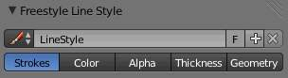
Line Style UI
In Freestyle, the line style settings define the appearance of a line set using five main aspects:
- stroke
- color
- alpha
- thickness
- geometry
These allow you to get many different styles of renders (technical draw, rough sketch, cartoon, oriental calligraphy, etc.).
You can create as many line styles as you wish, and reuse a given line style for several line sets by selecting it from the dropdown menu next to its name.
Note
Length Unit
Unless otherwise specified, all lengths in line style settings are in pixels (either relative or absolute, as specified in the core options).

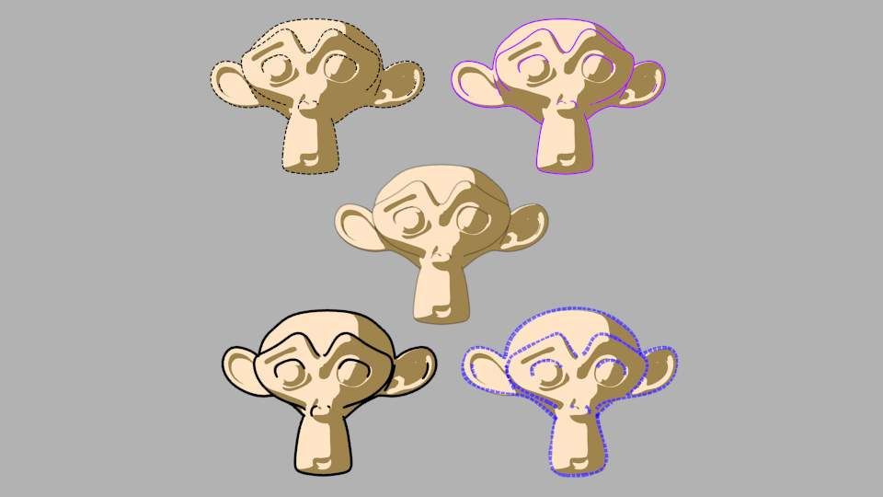
Line Style demo

Stroke

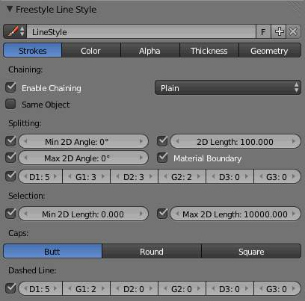
Stroke Line Style
Strokes are the final rendered lines. Yet you can tweaks them, for example, by removing the ones longer/shorter than some threshold, chaining lines into a single stroke or breaking a stroke into several ones based on angles, dashed pattern, etc.

Chaining
By default all retrieved lines from the line set are chained together. There are two basic chaining methods:
Plain
The default chaining method; it creates simple chains.
Sketchy
This chaining option allows for generating chains of feature edges with sketchy multiple strokes. Basically, it generates Round strokes instead of a single one. It is only really useful if you use some random-driven modifiers in the line style!
Rounds
It specifies the number of rounds in sketchy strokes.
Chaining can also be turned off to render each line separately, which can be useful for line styles which depend on accurate representation of the line set.
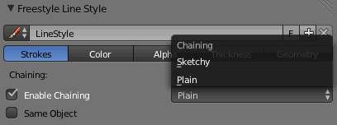
Chaining

Splitting
You can split up chains of Freestyle lines by checking one of the following:
Material Boundary
Splits chains of feature edges if they cross from one material to another.
Min 2D Angle and Max 2D Angle
Splits chains of feature edges when they make a 2D angle above (or below) a minimum (or maximum) threshold.
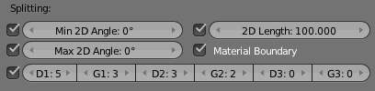
Splitting
2D Length
Splits chains when they are longer than the given value.
D1 / G1 / D2 / G2 / D3 / G3
Splits the chains using the given dashed pattern (“D” stands for “dash”, “G” stands for “gap”; see also Dashed Line).

Sorting
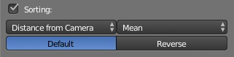
You can sort the order of your strokes, allowing the lines to stack in the order given.
Sort key
Choose which way you would like to sort your strokes.
Integration Type
Use in tandem with the Sort Key to determine the range for sorting
Sort Order
With the given result you can choose to “Reverse” the sort order

Selection
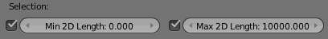
Selection
You can also choose to only select (i.e. render) chains longer than Min 2D Length and/or shorter than Max 2D Length.

Caps
You can choose between three types of line caps:
Butt
Flat cap, exactly at the point the line ends.
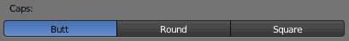
Line tip caps
Round
A half circle centered on the end point of the line.
Square
A square centered on the end point of the line (hence, like the circle, the drawn end of the line is slightly extended compared to its computed value).

Dashed Line
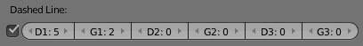
Dashes Line UI
By enabling the Dashed Line check box, you can specify three pairs of dash and gap lengths. Dash values define the lengths of dash strokes, while gap values specify intervals between two dashes.
If a zero gap is specified, then the corresponding dash is ignored even if it has a non-zero value.
Dashes are treated as separate strokes, meaning that you can apply line caps, as well as color, alpha and thickness modifiers.

Color

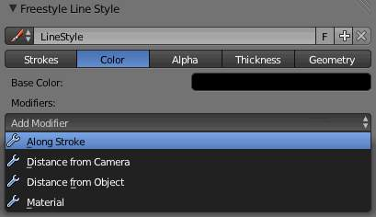
Line Style Color UI
In this tab you control the color of your strokes.
Base Color
The base color for this line style.

Modifiers
There are four color modifiers available, which can be mixed with the base color using the usual methods (see for example the Mix compositing node for further discussion of this topic). As with other modifier stacks in Bforartists, they are applied from top to bottom.
Influence
How much the result of this modifier affects the current color.

Along Stroke
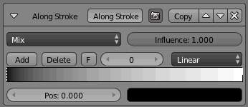
The Along Stroke modifier alters the base color with a new one from a given color ramp mapped along each stroke’s length. In other words, it applies a color ramp along each stroke.
Color Ramp
A standard Bforartists color ramp.

Distance from Camera
The Distance from Camera color modifier alters the base color with a new one from a given color ramp, using the distance to the active camera as the parameter.

Range Min and Range Max
The limits of the mapping from “distance to camera” to “color in ramp”. If the current point of the stroke is at Range Min or less from the active camera, it will take the start color of the ramp, and conversely, if it is at Range Max or more from the camera, it will take the end color of the ramp. These values are in the current scene’s units, not in pixels!
Fill Range by Selection
Set the min/max range values from the distances between the current selected objects and the camera.
The other settings are those of the standard Bforartists color ramp!

Distance from Object
The Distance from Object color modifier alters the base color with a new one from a given color ramp, using the distance to a given object as the parameter.

Target
The object to measure distance from.
Range Min and Range Max
The limits of the mapping from “distance to object” to “color in ramp”. If the current point of the stroke is at Range Min or less from the target, it will take the start color of the ramp, and conversely, if it is at Range Max or more from the target, it will take the end color of the ramp. These values are in the current scene’s units, not in pixels!
Fill Range by Selection
Set the min/max range values from the distances between the current selected objects and the target.
The other settings are those of the standard Bforartists color ramp!

Material
The Material color modifier alters the base color with a new one taken from the current material under the stroke.
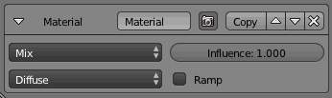
You can use various properties of the materials, among which many are mono-component (i.e. give B&W results). In this case, an optional color ramp can be used to map these grayscale values to colored ones.
If used with the Split by Material option in the Stroke tab, the result will not be blurred between materials along the strokes.
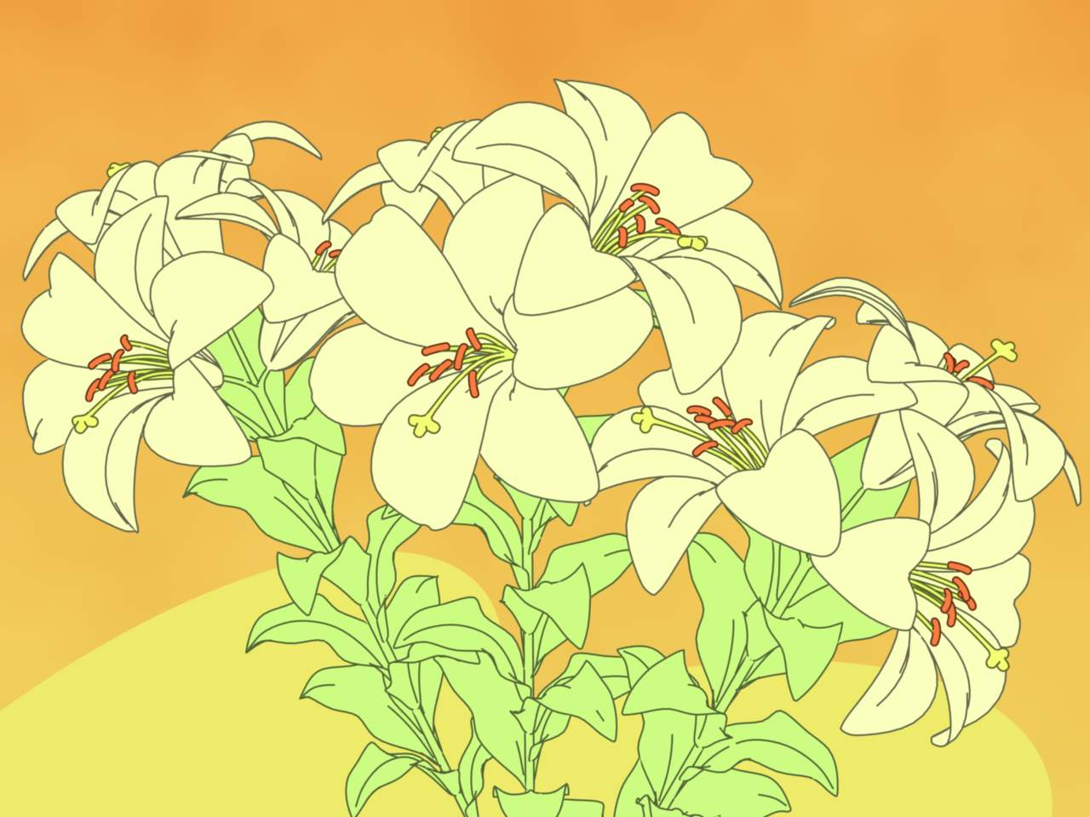
Material modifiers demo by T.K. File:Lilies_Color_Material.zip

Noise
The Noise modifier uses a pseudo-random number generator to variably distribute color along the stroke.
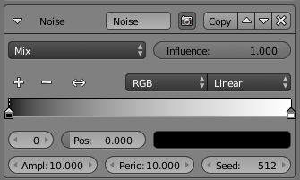
Amplitude
The maximum value of the noise. A higher amplitude means a less transparent (more solid) stroke.
Period
The period of the noise. This means how quickly the color value can change. A higher value means a more smoothly changing color along the stroke.
Seed
Seed used by the pseudo-random numer generator.
Color Ramp
A standard Bforartists color ramp that maps noise values to a stroke color.

Tangent
This modifier bases its effect on the traveling direction of the stroke evaluated at the stroke’s vertices.
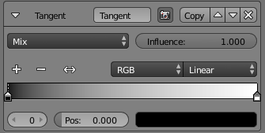
Color Ramp
A standard Bforartists color ramp that maps the traveling directio to a stroke color.
Min Angle and Max Angle
The range of input values to the mapping. Out-of-range input values will be clamped by the Min and Max angles and their corresponding color values.

3D Curvature
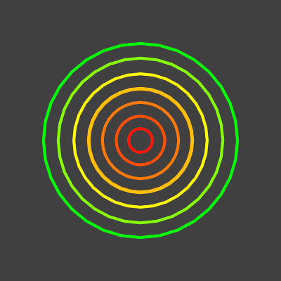
3D Curvature modifier demo by T.K. File:Render_freestyle_modifier_curvature_3d.blend
A modifier based on radial curvatures of the underlying 3D surface. The curvature of a 2D curve at a point is a measure of how quickly the curve turns at the point. The quicker the turn is, the larger the curvature is at the point. The curvature is zero if the curve is a straight line. Radial curvatures are those computed for a 2D curve that appears at the cross-section between the 3D surface and a plane defined by the view point (camera location) and the normal direction of the surface at the point.
For radial curvatures to be calculated (and therefore for this modifier to have any effect), the Face Smoothness option has to be turned on and the object needs to have Smooth Shading.

Color Ramp
A standard Bforartists color ramp that maps the radial curvature to a stroke color.
Min Curvature and Max Curvature
The limits of the color ramp. If the current point of the stroke is at Min Curvature or less from the target, it will take the start color of the mapping, and conversely, if it is at Max Curvature or more from the target, it will take the end color of the mapping.

Crease Angle

Crease Angle modifier demo by T.K. File:Render_freestyle_modifier_crease_angle.blend
A modifier based on the Crease Angle (angle between two adjacent faces). If a stroke segment doesn’t lie on a crease (i.e., the edge doesn’t have the Crease Angle nature), its color values are not touched by the modifier.
Color Ramp
A standard Bforartists color ramp that maps the crease angle to a stroke color.
Min Angle and Max Angle
The range of input values to the mapping. Out-of-range crease angle values will be clamped by the Min and Max angles and their corresponding color values.

Alpha

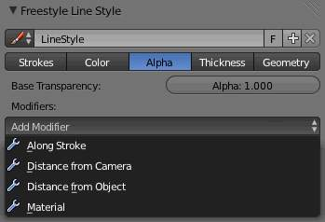
Line Style Alpha UI
In this tab you control the alpha (transparency) of your strokes.
Base Transparency
The base alpha for this line style.

Modifiers
There are four alpha modifiers available, which can be mixed with the base alpha using a subset of the usual methods (see for example the Mix compositing node for further discussion of this topic). As with other modifier stacks in Bforartists, they are applied from top to bottom.
Influence
How much the result of this modifier affects the current transparency.

Along Stroke
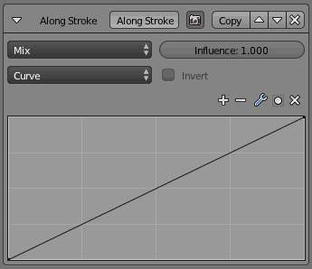
The Along Stroke modifier alters the base alpha with a new one from either a linear progression or a custom curve, mapped along each stroke’s length. In other words, it applies the selected progression along each stroke.
Mapping
Either a linear progression (from 0.0 to 1.0, which may be inverted with the Invert option), or a custom mapping curve.

Distance from Camera
The Distance from Camera modifier alters the base alpha with a new one from either a linear progression or a custom curve, using the distance to the active camera as parameter.
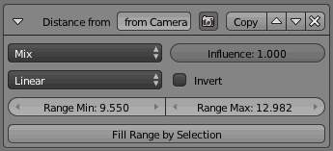
Mapping
Either a linear progression (from 0.0 to 1.0, which may be inverted with the Invert option), or a custom mapping curve.
Range Min and Range Max
The limits of the mapping from “distance to camera” to “alpha in mapping”. If the current point of the stroke is at Range Min or less from the active camera, it will take the start alpha of the mapping, and conversely, if it is at Range Max or more from the camera, it will take the end alpha of the mapping. These values are in the current scene’s units, not in pixels!
Fill Range by Selection
Set the min/max range values from the distances between the current selected objects and the camera.

Distance from Object
The Distance from Object modifier alters the base alpha with a new one from either a linear progression or a custom curve, using the distance to a given object as parameter.
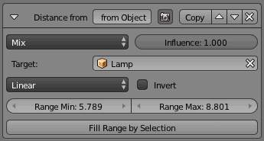
Target
The object to measure distance from.
Mapping
Either a linear progression (from 0.0 to 1.0, which may be inverted with the Invert option), or a custom mapping curve.
Range Min and Range Max
The limits of the mapping from “distance to object” to “alpha in mapping”. If the current point of the stroke is at Range Min or less from the target, it will take the start alpha of the mapping, and conversely, if it is at Range Max or more from the target, it will take the end alpha of the mapping. These values are in the current scene’s units, not in pixels!
Fill Range by Selection
Set the min/max range values from the distances between the current selected objects and the target.

Material
The Material modifier alters the base alpha with a new one taken from the current material under the stroke.
You can use various properties of the materials, among which some are multi-components (i.e. give RGB results). In that case, the mean value will be used.
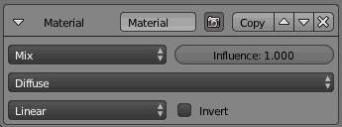
Mapping
Either a linear progression (from 0.0 to 1.0, which may be inverted with the Invert option), or a custom mapping curve. Note the linear non-inverted option is equivalent to “do nothing”, as original values from materials are already in the [0.0, 1.0] range.
If used with the Split by Material option in the Stroke tab, the result will not be blurred between materials along the strokes.

Noise
The Noise modifier uses a pseudo-random number generator to variably distribute transparency along the stroke.
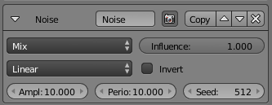
Amplitude
The maximum value of the noise. A higher amplitude means a less transparent (more solid) stroke.
Period
The period of the noise. This means how quickly the alpha value can change. A higher value means a more smoothly changing transparency along the stroke.
Seed
Seed used by the pseudo-random numer generator.
Mapping
Either a linear progression (from 0.0 to 1.0, which may be inverted with the Invert option), or a custom mapping curve. Note the linear non-inverted option is equivalent to “do nothing”, as original values from materials are already in the [0.0, 1.0] range.

Tangent
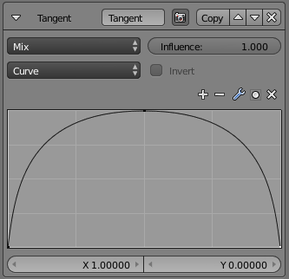
This modifier bases its effect on the traveling direction of the stroke evaluated at the stroke’s vertices.
Mapping
Either a linear progression (from 0.0 to 1.0, which may be inverted with the Invert option), or a custom mapping curve. Note the linear non-inverted option is equivalent to “do nothing”, as original values from materials are already in the [0.0, 1.0] range.
Min Angle and Max Angle
The range of input values to the mapping. Out-of-range input values will be clamped by the Min and Max angles and their corresponding alpha values.

3D Curvature
A modifier based on radial curvatures of the underlying 3D surface. The curvature of a 2D curve at a point is a measure of how quickly the curve turns at the point. The quicker the turn is, the larger the curvature is at the point. The curvature is zero if the curve is a straight line. Radial curvatures are those computed for a 2D curve that appears at the cross-section between the 3D surface and a plane defined by the view point (camera location) and the normal direction of the surface at the point.
For radial curvatures to be calculated (and therefore for this modifier to have any effect), the Face Smoothness option has to be turned on and the object needs to have Smooth Shading.
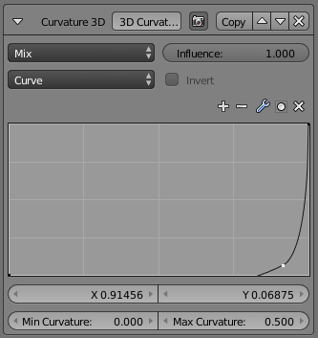
Mapping
Either a linear progression (from 0.0 to 1.0, which may be inverted with the Invert option), or a custom mapping curve. Note the linear non-inverted option is equivalent to “do nothing”, as original values from materials are already in the [0.0, 1.0] range.
Min Curvature and Max Curvature
The limits of the mapping. If the current point of the stroke is at Min Curvature or less from the target, it will take the start alpha of the mapping, and conversely, if it is at Max Curvature or more from the target, it will take the end alpha of the mapping.

Crease Angle
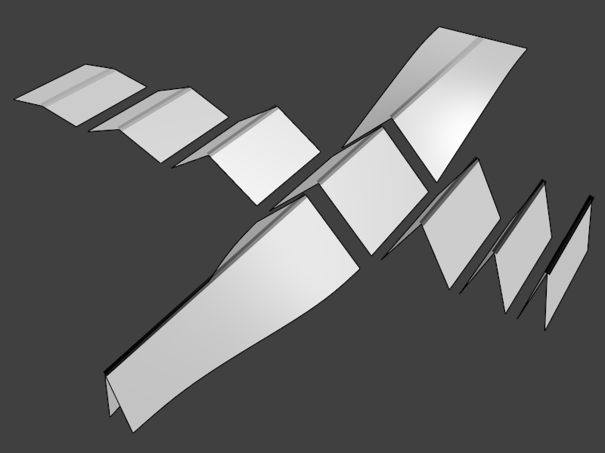
Crease Angle modifier demo by T.K. File:Render_freestyle_modifier_crease_angle.blend
A modifier based on the Crease Angle (angle between two adjacent faces). If a stroke segment doesn’t lie on a crease (i.e., the edge doesn’t have the Crease Angle nature), its alpha value is not touched by this modifier.
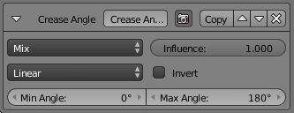
Mapping
Either a linear progression (from 0.0 to 1.0, which may be inverted with the Invert option), or a custom mapping curve. Note the linear non-inverted option is equivalent to “do nothing”, as original values from materials are already in the [0.0, 1.0] range.
Min Angle and Max Angle
The range of input values to the mapping. Out-of-range input values will be clamped by the Min and Max angles and their corresponding alpha values.

Thickness

In this tab you control the thickness of your strokes.
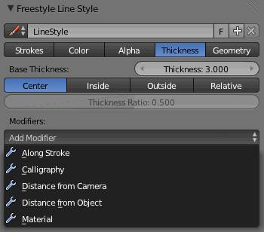
Base Thickness
The base thickness for this line style.
Thickness Position
Control the position of stroke thickness from the original (backbone) stroke geometry. There are four choices:
Center
The thickness is evenly split to the left and right side of the stroke geometry.
Inside
The strokes are drawn within object boundary.
Outside
The strokes are drawn outside the object boundary.
Relative
This allows you to specify the relative position by a number between 0.0 (inside) and 1.0 (outside), in the Thickness Ratio numeric field just below.
The thickness position options are applied only to strokes of edge types Silhouette and Border, since these are the only edge types defined in terms of the object boundary. Strokes of other edge types are always drawn using the Center option.

Modifiers
There are five thickness modifiers available, which can be mixed with the base thickness using a subset of the usual methods (see for example the Mix compositing node for further discussion of this topic). As with other modifier stacks in Bforartists, they are applied from top to bottom.
Influence
How much the result of this modifier affects the current thickness.

Along Stroke
The Along Stroke modifier alters the base thickness with a new one from either a linear progression or a custom curve, mapped along each stroke’s length. In other words, it applies the selected progression along each stroke.
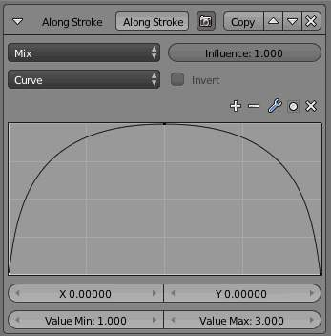
Mapping
Either a linear progression (from 0.0 to 1.0 which may be inverted with the Invert option), or a custom mapping curve.

Calligraphy
The Calligraphy modifier mimics some broad and flat pens for calligraphy. It generates different thickness based on the orientation of the stroke.
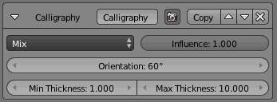
Orientation
The angle (orientation) of the virtual drawing tool, from the vertical axis of the picture. For example, an angle of 0.0 mimics a pen aligned with the vertical axis, hence the thickest strokes will be the vertical ones, and the thinnest, the horizontal ones.
Min Thickness and Max Thickness
The minimum and maximum generated thickness (as explained above, minimum is used when the stroke’s direction is perpendicular to the main Orientation, and maximum, when aligned with it).
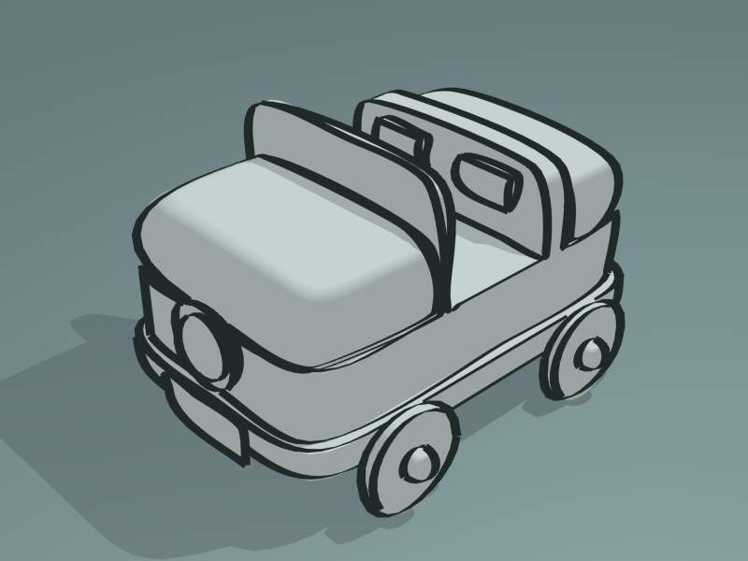
Calligraphy modifier demo by T.K. File:Toycar_Calligraphy.zip

Distance from Camera
The Distance from Camera modifier alters the base thickness with a new one from either a linear progression or a custom curve, using the distance to the active camera as the parameter.
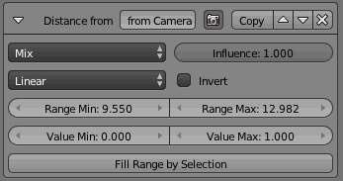
Mapping
Either a linear progression (from 0.0 to 1.0 which may be inverted with the Invert option), or a custom mapping curve.
Range Min and Range Max
The limits of the mapping from “distance to camera” to “thickness in mapping”. If the current point of the stroke is at Range Min or less from the active camera, it will take the start thickness of the mapping, and conversely, if it is at Range Max or more from the camera, it will take the end thickness of the mapping. These values are in the current scene’s units, not in pixels!
Fill Range by Selection
Set the min/max range values from the distances between the current selected objects and the camera.

Distance from Object
The Distance from Object modifier alters the base thickness with a new one from either a linear progression or a custom curve, using the distance to a given object as parameter.
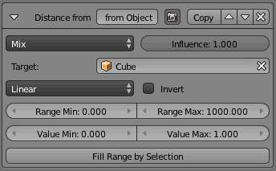
Target
The object to measure distance from.
Mapping
Either a linear progression (from 0.0 to 1.0 which may be inverted with the Invert option), or a custom mapping curve.
Range Min and Range Max
The limits of the mapping from “distance to object” to “alpha in mapping”. If the current point of the stroke is at Range Min or less from the target, it will take the start thickness of the mapping, and conversely, if it is at Range Max or more from the target, it will take the end thickness of the mapping. These values are in the current scene’s units, not in pixels!
Fill Range by Selection
Set the min/max range values from the distances between the current selected objects and the target.

Material
The Material modifier alters the base thickness with a new one taken from the current material under the stroke.
You can use various properties of the materials, among which some are multi-components (i.e. give RGB results). In that case, the mean value will be used.
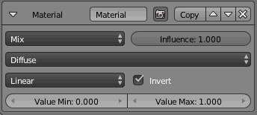
Mapping
Either a linear progression (from 0.0 to 1.0 which may be inverted with the Invert option), or a custom mapping curve. Note the linear non-inverted option is equivalent to “do nothing”, as original values from materials are already in the [0.0, 1.0] range...
If used with the Split by Material option in the Stroke tab, the result will not be blurred between materials along the strokes.

Noise
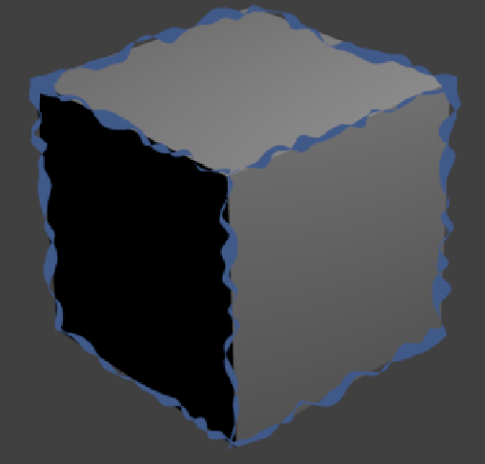
Effect generated with a noise thickness modifier using asymmetric thickness.
The Noise modifier uses a pseudo-random number generator to variably distribute thickness along the stroke.
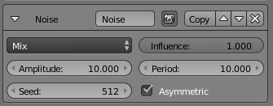
Min Thickness and Max Thickness
The minimum and maximum assigned thickness.
Asymmetric
Allows the thickness to be distributed unevenly at every point. Internally, the stroke is represented as a backbone with a thickness to the right and left side. All other thickness shaders make sure that the left and right thickness values are equal. For the Noise shader however, a meaningful (and good-looking) result can be created by assigning different values to either side of the backbone.

Tangent
This modifier bases its effect on the traveling direction of the stroke evaluated at the stroke’s vertices.
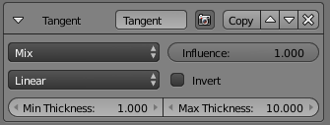
Min Thickness and Max Thickness
The minimum and maximum assigned thickness.
Mapping
Either a linear progression (from Min Thickness to Max Thickness, which may be inverted with the Invert option), or a custom mapping curve (on the same range).
Min Angle and Max Angle
The range of input values to the mapping. Out-of-range input values will be clamped by the Min and Max angles and their corresponding thickness values.

3D Curvature
A modifier based on radial curvatures of the underlying 3D surface. The curvature of a 2D curve at a point is a measure of how quickly the curve turns at the point. The quicker the turn is, the larger the curvature is at the point. The curvature is zero if the curve is a straight line. Radial curvatures are those computed for a 2D curve that appears at the cross-section between the 3D surface and a plane defined by the view point (camera location) and the normal direction of the surface at the point.
For radial curvatures to be calculated (and therefore for this modifier to have any effect), the Face Smoothness option has to be turned on and the object needs to have Smooth Shading.
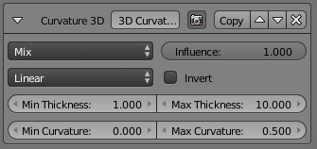
Min Thickness and Max Thickness
The minimum and maximum assigned thickness.
Mapping
Either a linear progression (from Min Thickness to Max Thickness, which may be inverted with the Invert option), or a custom mapping curve (on the same range).
Min Curvature and Max Curvature
The limits of the mapping of the Min and Max Thickness. If the current point of the stroke is at Min Curvature or less from the target, it will take the start thickness of the mapping, and conversely, if it is at Max Curvature or more from the target, it will take the end thickness of the mapping.

Crease Angle
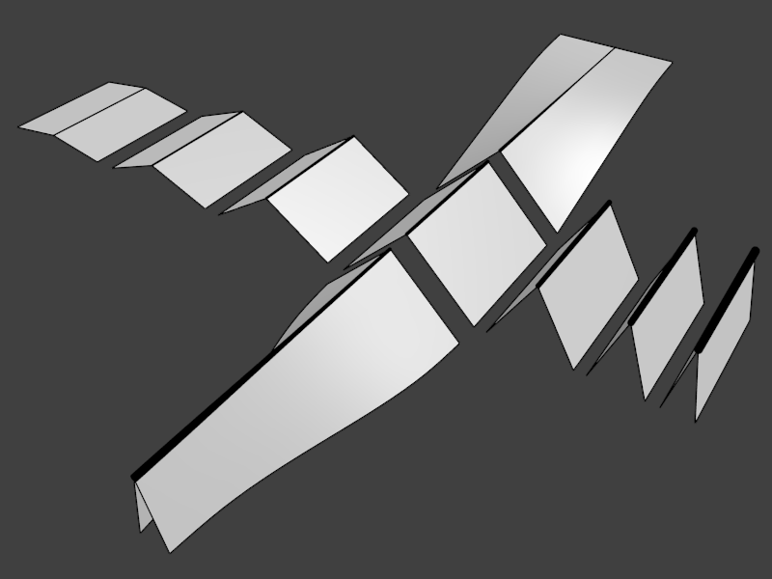
Crease Angle modifier demo by T.K. File:Render_freestyle_modifier_crease_angle.blend
A modifier based on the Crease Angle (angle between two adjacent faces). If a stroke segment doesn’t lie on a crease (i.e., the edge doesn’t have the Crease Angle nature), its thickness value is not touched by this modifier.
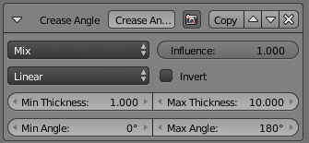
Min Thickness and Max Thickness
The minimum and maximum assigned thickness.
Mapping
Either a linear progression (from Min Thickness to Max Thickness, which may be inverted with the Invert option), or a custom mapping curve (on the same range).

Geometry

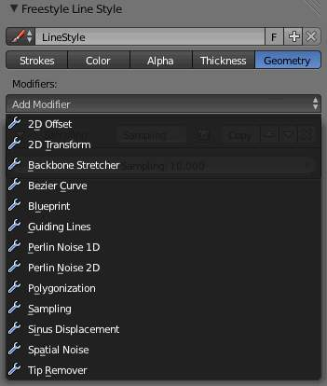
Line Style Geometry Overall UI
In this tab you control the geometry of your strokes.

Modifiers
There are thirteen geometry modifiers available. These modifiers have no mix nor influence settings, as they always completely apply to the strokes’ geometry (like object modifiers do). They take the resulting two-dimensional strokes from the Freestyle line set and displace or deform them in various ways.
As with other modifier stacks in Bforartists, they are applied from top to bottom.

2D Offset
The 2D Offset modifier adds some two-dimensional offsets to the stroke backbone geometry. It has two sets of independent options/effects:
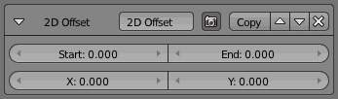
Start and End
These two options add the given amount of offset to the start (or end) point of the stroke, along the (2D) normal at those points. The effect is blended over the whole stroke, so if you, for example, set only Start to 50, the start of the stroke is offset 50 pixels along its normal, the middle of the stroke, 25 pixels along its own normal, and the end point isn’t moved.
X and Y
These two options simply add a constant horizontal and/or vertical offset to the whole stroke.

2D Transform
The 2D Transform modifier applies two-dimensional scaling and/or rotation to the stroke backbone geometry. Scale is applied before rotation.
The center (pivot point) of these 2D transformations can be:
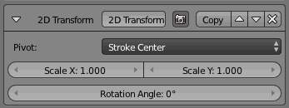
Stroke Center
The median point of the stroke.
Stroke Start
The beginning point of the stroke.
Stroke End
The end point of the stroke.
Stroke Point Parameter
The Stroke Point Parameter factor controls where along the stroke the pivot point is (0.0 means start point; 1.0 end point).
Absolute 2D Point
The Pivot X and Pivot Y allows you to define the position of the pivot point in the final render (from the bottom left corner). WARNING : Currently, you have to take into account the real render size, i.e. resolution and resolution percentage!
Scale X and Scale Y
The scaling factors, in their respective axes.
Rotation Angle
The rotation angle.
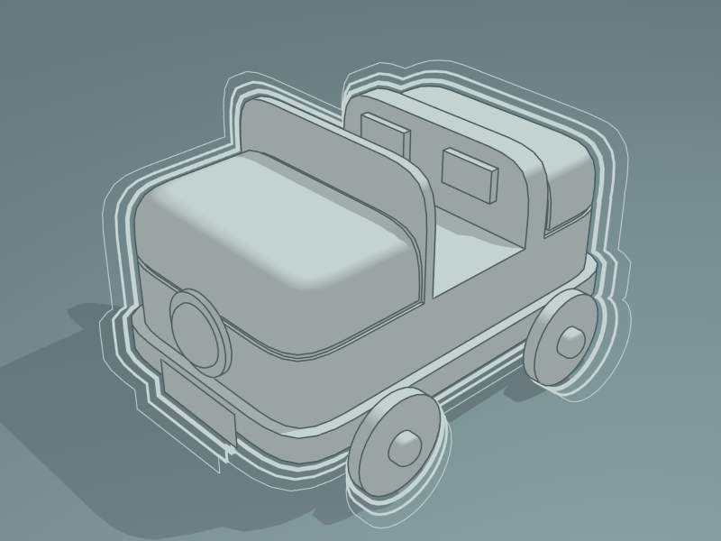
2D Transform modifier File:Toycar_Three_Contours.zip

Backbone Stretcher
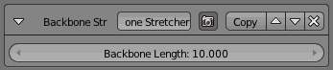
The Backbone Stretcher modifier stretches (adds some length to) the beginning and end of the stroke.
Backbone Length
Length to add to the strokes’ ends.

Bezier Curve
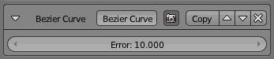
The Bezier Curve modifier replaces the stroke by a Bezier approximation of it.
Error
The maximum distance allowed between the new Bezier curve and the original stroke.
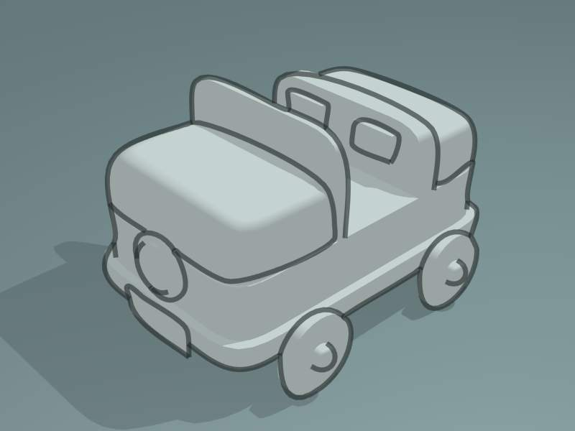
Bezier Curve modifier demo by T.K. File:toycar_bezier.zip

Blueprint
The Blueprint modifier produces blueprint-like strokes using either circular, elliptical, or square contours. A blueprint here refers to those lines drawn at the beginning of free-hand drawing to capture the silhouette of objects with a simple shape such as circles, ellipses and squares.
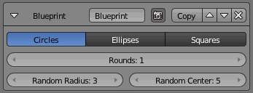
Shape
Which base shapes to use for this blueprint: Circles, Ellipses or Squares.
Rounds
How many rounds are generated, as if the pen draws the same stroke several times (i.e. how many times the process is repeated).
Random Radius and Random Center
For the Circles and Ellipses shapes. Adds some randomness to each round in the relevant aspect. Using more than one round with no randomness would be meaningless, as they would draw over each other exactly.
Backbone Length and Random Backbone
For the Squares shapes. The first adds some extra length to each edge of the generated squares (also affected by the second parameter). The second adds some randomness to the squares.
Note that the Min 2D Length feature from the Strokes settings is quite handy here, to avoid the noise generated by small strokes...

Guiding Lines
The Guiding Lines modifier replaces a stroke by a straight line connecting both of its ends.
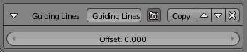
Offset
Offset the start and end points along the original stroke, before generating the new straight one.
This modifier will produce reasonable results when strokes are short enough, because shorter strokes are more likely to be well approximated by straight lines. Therefore, it is recommended to use this modifier together with one of the splitting options (by 2D angle or by 2D length) from the Strokes panel.
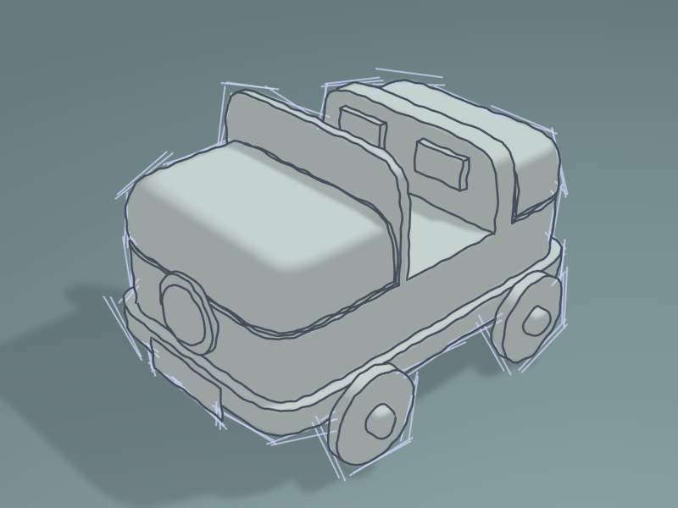
Guiding Lines modifier Demo by T.K. File:Toycar_Guiding_Line.zip

Perlin Noise 1D
The Perlin Noise 1D modifier adds one-dimensional Perlin noise to the stroke. The curvilinear abscissa (value between 0 and 1 determined by a point’s position relative to the first and last point of a stroke) is used as the input to the noise function to generate noisy displacements.
This means that this modifier will give an identical result for two strokes with the same length and sampling interval.
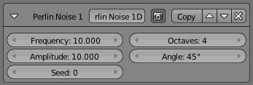
Frequency
How dense the noise is (kind of a scale factor along the stroke).
Amplitude
How much the noise distorts the stroke in the Angle direction.
Seed
The seed of the random generator (the same seed over a stroke will always give the same result).
Octaves
The “level of detail” of the noise.
Angle
In which direction the noise is applied (0.0 is fully horizontal).

Perlin Noise 2D
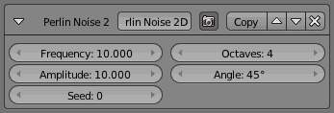
The Perlin Noise 2D modifier adds one-dimensional Perlin noise to the stroke. The modifier generates noisy displacements using 2D coordinates of stroke vertices as the input of the noise generator.
Its settings are exactly the same as the Perlin Noise 1D modifier.

Polygonization
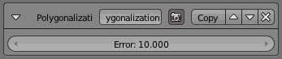
The Polygonization modifier simplifies strokes as much as possible (in other words, it transforms smooth strokes into jagged polylines).
Error
The maximum distance allowed between the new simplified stroke and the original one (the larger this value is, the more jagged/approximated the resulting polylines are).

Sampling
The Sampling modifier changes the definition, precision of the stroke, for the following modifiers.
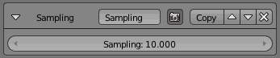
Sampling
The smaller this value, the more precise are the strokes. Be careful; too small values will require a huge amount of time and memory during render!

Sinus Displacement
The Sinus Displacement modifier adds a sinusoidal displacement to the stroke.
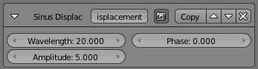
Wavelength
How wide the undulations are along the stroke.
Amplitude
How high the undulations are across the stroke.
Phase
Allows “offsetting” (“moving”) the undulations along the stroke.
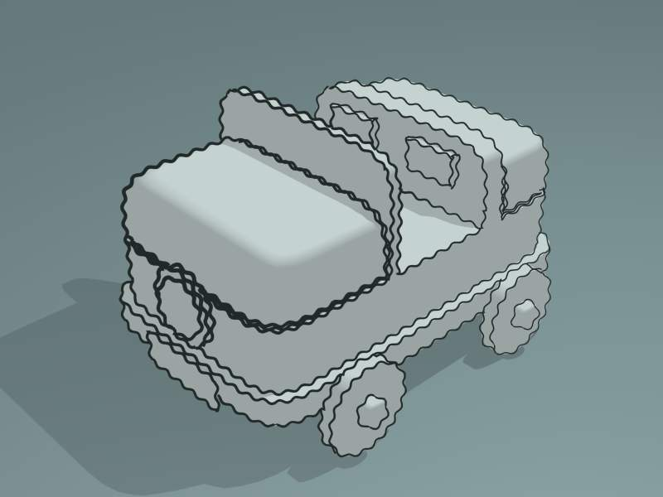
Sinus Displacement modifier demo by T.K. File:Toycar_Sinus.zip

Spatial Noise
The Spatial Noise modifier adds some spatial noise to the stroke. Spatial noise displacements are added in the normal direction (i.e., the direction perpendicular to the tangent line) evaluated at each stroke vertex.
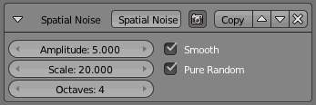
Amplitude
How much the noise distorts the stroke.
Scale
How wide the noise is along the stroke.
Octaves
The level of detail of the noise.
Smooth
When enabled, apply some smoothing over the generated noise.
Pure Random
When disabled, the next generated random value depends on the previous one; otherwise they are completely independent. Disabling this setting gives a more “consistent” noise along a stroke.

Tip Remover
The Tip Remover modifier removes a piece of the stroke at its beginning and end.
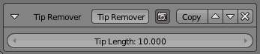
Tip Length
Length of stroke to remove at both of its tips.

Simplification
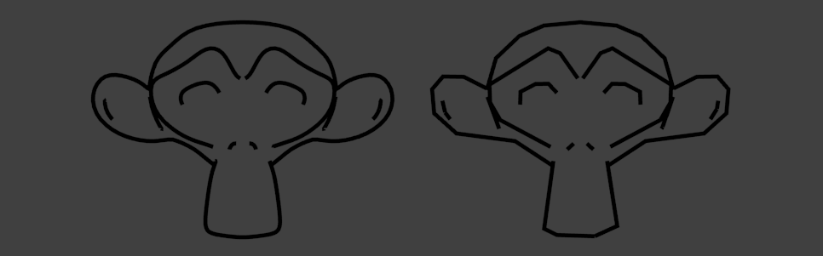
The Simplification modifier merges stroke vertices that lie close to one another, like the Decimate modifier for meshes.
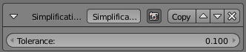
Tolerance
Measure for how close points have to be to each other to be merged. A higher tolerance means more vertices are merged.

Python Scripting Mode

The Python Scripting mode offers full programmability for line stylization. In this control mode, all stylization operations are written as Python scripts referred to as style modules in the Freestyle terminology. The input to a style module is a view map (i.e., a set of detected feature edges), and the output is a set of stylized strokes.
A style module is composed of successive calls of five basic operators: selection, chaining, splitting, sorting and stroke creation. The selection operator identifies a subset of input feature edges based on one or more user-defined selection conditions (predicates). The selected edges are processed with the chaining, splitting and sorting operators to build chains of feature edges. These operators are also controlled by user-supplied predicates and functions in order to determine how to transform the feature edges into chains. Finally, the chains are transformed into stylized strokes by the stroke creation operator, which takes a list of user-defined stroke shaders.
Python style modules are stored within .blend files as text data-blocks. External style module files first need to be loaded in the Text Editor window. Then the pull-down menu within an entry of the style module stack allows you to select a module from the list of loaded style modules.
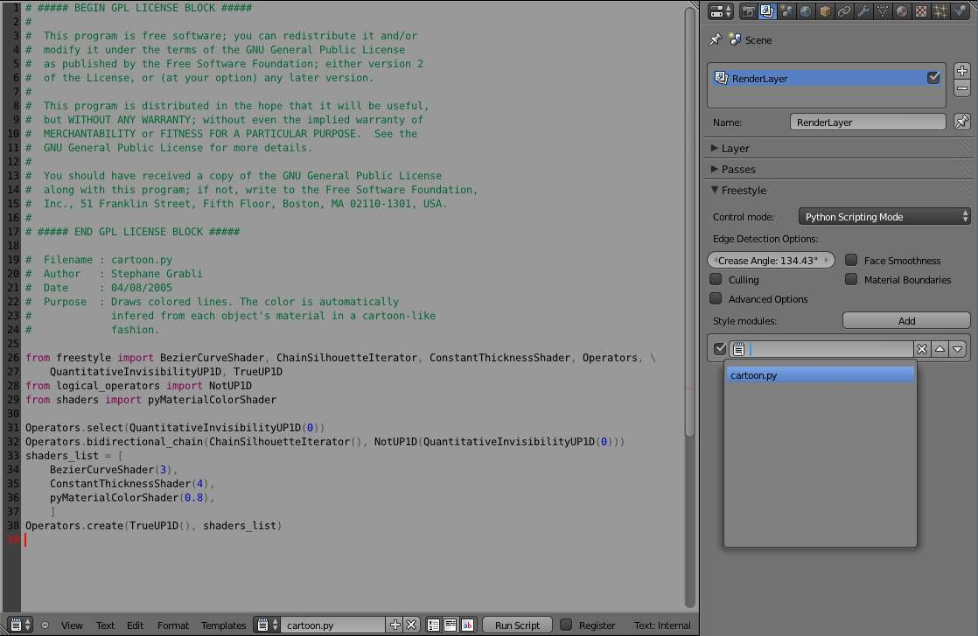
A screen capture of a style module (cartoon.py) loaded in the Text Editor window (left), as well as Freestyle options in the Python Scripting mode in the Render Layers buttons (right)
Freestyle for Bforartists comes with a number of Python style modules that can serve as a starting point of your own style module writing. See also the section of the Freestyle Python API in the Bforartists Python API reference manual for the full detail of style module constructs.
  By T.K. using the Python Scripting mode  (File:Turning_Pages.zip, CC0) | 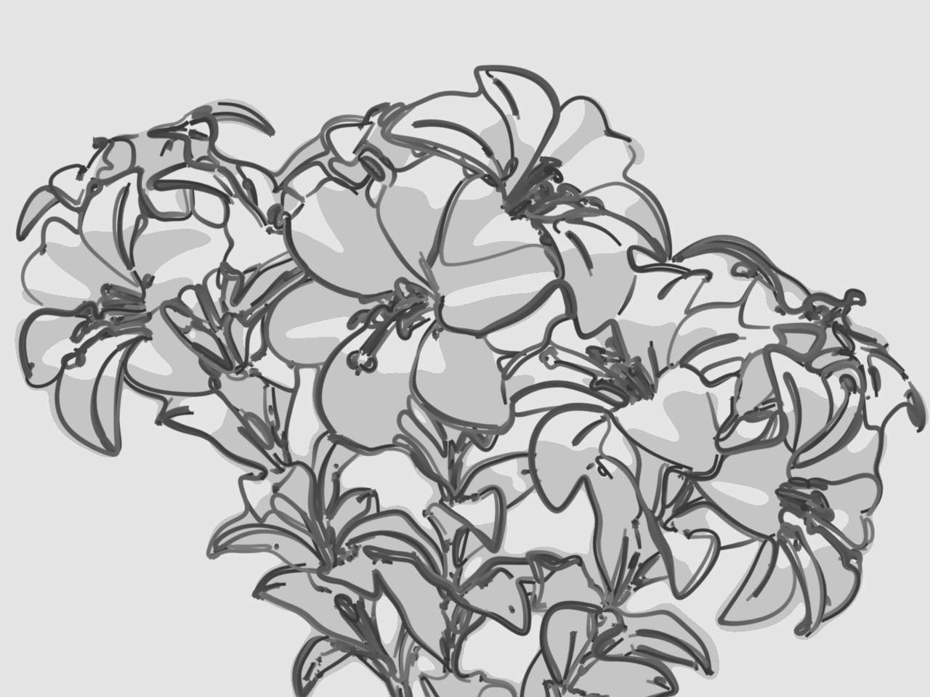  By T.K. using the Python Scripting mode  (File:Lily_Broken_Topology.zip, CC0)

Writing Style Modules
A style module is a piece of code responsible for the stylization of Freestyle line drawing. The input of a style module is a set of feature edges called view map (ViewMap). The output is a set of stylized lines also referred to as strokes. A style module is structured as a pipeline of operations that allow for building strokes from the input edges within the view map.
There are five kinds of operations (listed with corresponding operator functions):
- Selection Operators.select()
- Chaining Operators.chain(), Operators.bidirectional_chain()
- Splitting Operators.sequential_split(), Operators.recursive_split()
- Sorting Operators.sort()
- Stroke creation Operators.create()
The input view map is populated with a set of ViewEdge objects. The selection operation is used to pick up ViewEdges of interest to artists based on user-defined selection conditions (predicates). Chaining operations take the subset of ViewEdges and build Chains by concatenating ViewEdges according to user-defined predicates and functions. The Chains can be further refined by splitting them into smaller pieces (e.g., at points where edges make an acute turn) and selecting a fraction of them (e.g., to keep only those longer than a length threshold). The sorting operation is used to arrange the stacking order of chains to draw one line on top of another. The chains are finally transformed into stylized strokes by the stroke creation operation applying a series of stroke shaders to individual chains.
ViewEdges, Chains and Strokes are generically referred to as one-dimensional (1D) elements. A 1D element is a polyline that is a series of connected straight lines. Vertices of 1D elements are called 0D elements in general.
All the operators act on a set of active 1D elements. The initial active set is the set of ViewEdges in the input view map. The active set is updated by the operators.

Selection
The selection operator goes through every element of the active set and keeps only the ones satisfying a certain predicate. The Operators.select() method takes as the argument a unary predicate that works on any Interface1D that represents a 1D element. For example:
Operators.select(QuantitativeInvisibilityUP1D(0))
This selection operation uses the QuantitativeInvisibilityUP1D predicate to select only the visible ViewEdge (more precisely, those whose quantitative invisibility is equal to 0). The selection operator is intended to selectively apply the style to a fraction of the active 1D elements.
It is noted that QuantitativeInvisibilityUP1D is a class implementing the predicate that tests line visibility, and the Operators.select() method takes an instance of the predicate class as argument. The testing of the predicate for a given 1D element is actually done by calling the predicate instance, that is, by invoking the __call__ method of the predicate class. In other words, the Operators.select() method takes as argument a functor which in turn takes an Interface0D object as argument. The Freestyle Python API employs functors extensively to implement predicates, as well as functions.

Chaining
The chaining operators act on the set of active ViewEdge objects and determine the topology of the future strokes. The idea is to implement an iterator to traverse the ViewMap graph by marching along ViewEdges. The iterator defines a chaining rule that determines the next ViewEdge to follow at a given vertex (see ViewEdgeIterator). Several such iterators are provided as part of the Freestyle Python API (see ChainPredicateIterator and ChainSilhouetteIterator). Custom iterators can be defined by inheriting the ViewEdgeIterator class. The chaining operator also takes as argument a UnaryPredicate working on Interface1D as a stopping criterion. The chaining stops when the iterator has reached a ViewEdge satisfying this predicate during the march along the graph.
Chaining can be either unidirectional Operators.chain() or bidirectional Operators.bidirectional_chain(). In the latter case, the chaining will propagate in the two directions from the starting edge.
The following is a code example of bidirectional chaining:
Operators.bidirectional_chain(
ChainSilhouetteIterator(),
NotUP1D(QuantitativeInvisibilityUP1D(0)),
)
The chaining operator uses the ChainSilhouetteIterator as the chaining rule and stops chaining as soon as the iterator has come to an invisible ViewEdge.
The chaining operators process the set of active ViewEdge objects in order. The active ViewEdges can be previously sorted using the Operators.sort() method (see below). It starts a chain with the first ViewEdge of the active set. All ViewEdges that have already been involved in the chaining process are marked (in the case of the example above, the time stamp of each ViewEdge is modified by default), in order not to process the same ViewEdge twice. Once the chaining reaches a ViewEdge that satisfies the stopping predicate, the chain is terminated. Then a new chain is started from the first unmarked ViewEdge in the active set. This operation is repeated until the last unmarked ViewEdge of the active set was processed. At the end of the chaining operation, the active set is set to the Chains that have just been constructed.

Splitting
The splitting operation is used to refine the topology of each Chain. Splitting is performed either sequentially or recursively. Sequential splitting Operators.sequentialSplit() in its basic form, parses the Chain at a given arbitrary resolution and evaluates a unary predicate (working on 0D elements) at each point along the Chain. Every time the predicate is satisfied, the chain is split into two chains. At the end of the sequential split operation, the active set of chains is set to the new chains.
Operators.sequentialSplit(TrueUP0D(), 2)
In this example, the chain is split every 2 units. A more elaborated version uses two predicates instead of one: One to determine the starting point of the new chain and the other to determine its ending point. This second version can lead to a set of Chains that are disjoint or that overlap if the two predicates are different. (see Operators.sequentialSplit() for more details).
Recursive splitting Operators.recursiveSplit() evaluates a function on the 0D elements along the Chain at a given resolution and find the point that gives the maximum value for the function. The Chain is then split into two at that point. This process is recursively repeated on each of the two new Chains, until the input Chain satisfies a user-specified stopping condition.
func = Curvature2DAngleF0D()
Operators.recursive_split(func, NotUP1D(HigherLengthUP1D(5)), 5)
In the code example above, the Chains are recursively split at points of the highest 2D curvature. The curvature is evaluated at points along the Chain at a resolution of 5 units. Chains shorter than 5 units won’t be split anymore.

Sorting
The sorting operator Operators.sort() arranges the stacking order of active 1D elements. It takes as argument a binary predicate used as a “smaller than” operator to order two 1D elements.
Operators.sort(Length2DBP1D())
In this code example, the sorting uses the Length2DBP1D binary predicate to sort the Interface1D objects in the ascending order in terms of 2D length.
The sorting is particularly useful when combined with causal density. Indeed, the causal density evaluates the density of the resulting image as it is modified. If we wish to use such a tool to decide to remove strokes whenever the local density is too high, it is important to control the order in which the strokes are drawn. In this case, we would use the sorting operator to insure that the most “important” lines are drawn first.

Stroke creation
Finally, the stroke creation operator Operators.create() takes the active set of Chains as input and build Strokes. The operator takes two arguments. The first is a unary predicate that works on Interface1D that is designed to make a last selection on the set of chains. A Chain that doesn’t satisfy the condition won’t lead to a Stroke. The second input is a list of shaders that will be responsible for the shading of each built stroke.
shaders_list = [
SamplingShader(5.0),
ConstantThicknessShader(2),
ConstantColorShader(0.2,0.2,0.2,1),
]
Operators.create(DensityUP1D(8,0.1, IntegrationType.MEAN), shaders_list)
In this example, the DensityUP1D predicate is used to remove all Chains whose mean density is higher than 0.1. Each chain is transformed into a stroke by resampling it so as to have a point every 5 units and assigning to it a constant thickness of 2 units and a dark gray constant color.

User control on the pipeline definition
Style module writing offers different types of user control, even though individual style modules have a fixed pipeline structure. One is the sequencing of different pipeline control structures, and another is through the definition of functor objects that are passed as argument all along the pipeline.
Different pipeline control structures can be defined by sequencing the selection, chaining, splitting, and sorting operations. The stroke creation is always the last operation that concludes a style module.
Predicates, functions, chaining iterators, and stroke shaders can be defined by inheriting base classes and overriding appropriate methods. See the reference manual entries of the following base classes for more information on the user-scriptable constructs.
- UnaryPredicate0D  - UnaryPredicate1D  - BinaryPredicate0D  - BinaryPredicate1D  - UnaryFunction0DDouble  - UnaryFunction0DEdgeNature  - UnaryFunction0DFloat  - UnaryFunction0DId  - UnaryFunction0DMaterial  - UnaryFunction0DUnsigned  - UnaryFunction0DVec2f  - UnaryFunction0DVec3f | - UnaryFunction0DVectorViewShape  - UnaryFunction0DViewShape  - UnaryFunction1DDouble  - UnaryFunction1DEdgeNature  - UnaryFunction1DFloat  - UnaryFunction1DUnsigned  - UnaryFunction1DVec2f  - UnaryFunction1DVec3f  - UnaryFunction1DVectorViewShape  - UnaryFunction1DVoid  - ViewEdgeIterator  - StrokeShader

Freestyle SVG Exporter

SVG exporting for Freestyle is available through an addon.
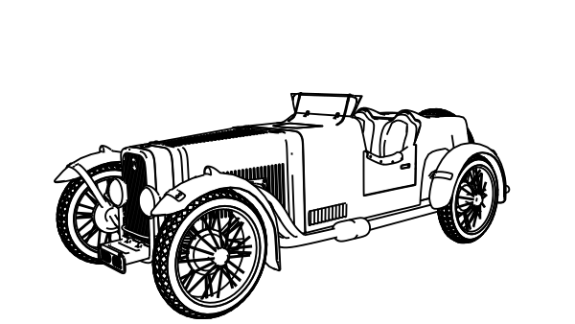
An example of a .svg result produced by the Freestyle SVG Exporter. Model by Bforartistsgoodies
This addon can be enabled via User Preferences > Addons > Render:Freestyle SVG Exporter. The GUI for the exporter should now be visible in the render tab of the properties window. The exported .svg file is written to the default output path (Properties > Render > Output).

Options
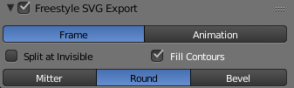
Mode
Option between Frame and Animation. Frame will render a single frame, Animation will bundle all rendered frames into a single .svg file.
Split at Invisible
By default the exporter won’t take invisible vertices into account and export them like they are visible. Some stroke modifiers, like Blueprint, mark vertices as invisible to achieve a certain effect. Enabling this option will make the paths split when encountering an invisible vertex, which leads to a better result.
Fill Contours
The contour of objects is filled with their material color. Note that this features is somewhat unstable - especially with animations.
Stroke Cap Style
Defines the style the stroke caps will have in the SVG output.

Exportable Properties
Because the representation of Freestyle strokes and SVG path objects is fundamentally different, a one on one translation between Freestyle and SVG is not possible. The main shortcoming of SVG compared to Freestyle is that Freestyle defines style per-point, where SVG defines it per-path. This means that Freestyle can produce much more complex results that are impossible to achieve in SVG.
The properties that can be exported are:
- Base color
- Base alpha
- Base thickness
- Dashes

Animations
The exporter supports the creation of SVG animations. When the Mode is set to Animation, all frames from a render - one when rendering a frame (f12) or all when rendering an animation (shift f12) - into a single file. Most modern browsers support the rendering of SVG animations.
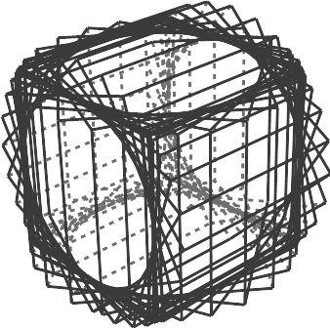
An SVG animation rendered with the exporter.

Exporting Fills
Fills are colored areas extracted from a Freestyle render result. Specifically, they are defined by a combination of the Contour and External Contour edge type, combined with some predicates. The fill result can be unexpected, when the SVG renderer cannot correctly draw the path that the exporter has generated. This problem is extra apparent in animations.
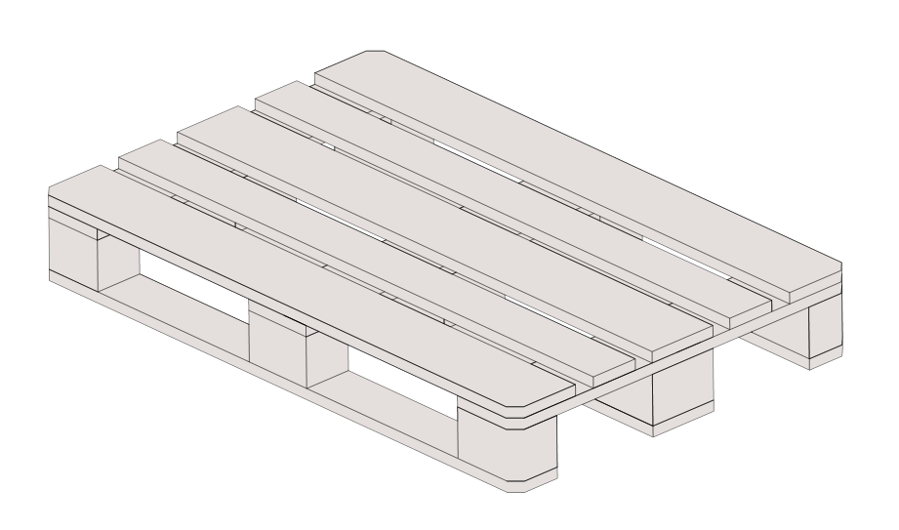
An example of a .svg result produced by the Freestyle SVG Exporter. Model by Julien Deswaef
Fills support holes and layering. When using layers, the exporter tries to render objects with the same material as the patch. The exporting of fills and especially the order in which they are layered is by no means perfect. In most cases, these problems can be easily solved in Inkscape or a text editor.

Link

Here are some links to external data regarding Freestyle.

Video
https://www.youtube.com/watch?v=IY1L76WwOHg
The Light At The End.
https://www.youtube.com/watch?v=4pOsmLV0-BA
mmd_tools test2 with Bforartists+Freestyle (未来時計 AM4:30)

Video Tutorial
https://www.youtube.com/watch?v=1T_impeCV-0
Using freestyle in Bforartists
https://www.youtube.com/watch?v=Uq1-KoZ7Uv4
Tutorial: Bforartists 3D - Freestyle and Composite
https://www.youtube.com/watch?v=J3LI_MTnY7U
Bforartists Tutorial: Freestyle

Tutorial
Freestyle basics
http://studiollb.wordpress.com/2012/02/29/freestyle-introductory-tutorial/ http://jikz.net/archives/364 http://jikz.net/archives/329
Edge types
https://studiollb.wordpress.com/2012/09/08/freestyle-101-edge-types/
Line style basic
http://studiollb.wordpress.com/2012/09/08/freestyle-101-line-style-basic/
Line style modifiers
http://studiollb.wordpress.com/2012/09/08/freestyle-101-line-style-modifier-part-1/ http://studiollb.wordpress.com/2012/09/08/freestyle-101-line-style-modifier-part-2/ http://studiollb.wordpress.com/2012/09/15/freestyle-101-planning-and-along-stroke-line-style-modifier/
Tips and tricks
http://studiollb.wordpress.com/2012/02/03/freestyle-tips/ (Old)
Misc

- FreeStyle Users’ improvement suggestions.
- FreeStyle integration into Bforartists blog
Early documentation of FreeStyle

